Table of contents

2

Fixed LOD Calculation 2

Sheet Preparation 2

Now taking place use FIXED Calculations. 5

Let’s use newly created calculation field at our sheet. 6

Include LOD Calculation 7

Sheet Preparation 7

Included House Income by Year 8

Let’s use newly created calculation field at our sheet. 9

Functions Over LOD Calculations 10

Creating complicated calculated field. 10

Using Average Max Count by Year 10

Exclude LOD Calculation 12

Creation of Exclude Calculation Field 12

Using Exclude LOD Calculation field 13

Final Sheet 17

Sheet Preparing 17

Using all LOD Calculation fields 18

# Fixed LOD Calculation



Fixed LOD Calculation



Include LOD Calculation

Functions Over LOD Calculations

Exclude LOD Calculation

Final Sheet

## Sheet Preparation

Through all examples, we will use one Data Source located at same named folder. Please load this file and go on Sheet1 for starting using LOD functionality.

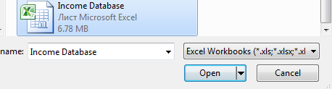

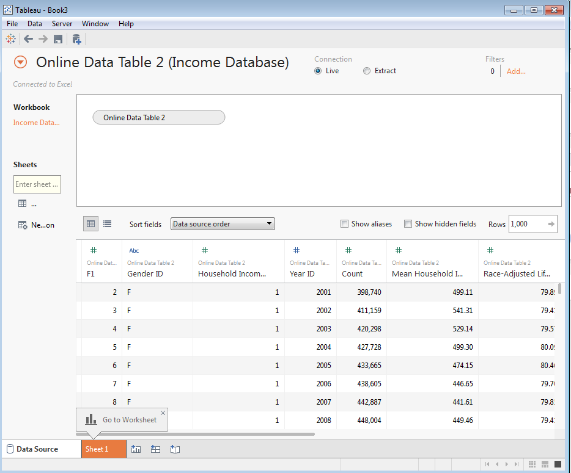

As first example, we will try to display House holding Income per Year Id and try to use for it LOD Fixed Calculation.



Fixed LOD Calculation



Include LOD Calculation

Functions Over LOD Calculations

Exclude LOD Calculation

Final Sheet

At first, we will set Year Id as Columns and Measure summary of Household Income Percentile as Rows.

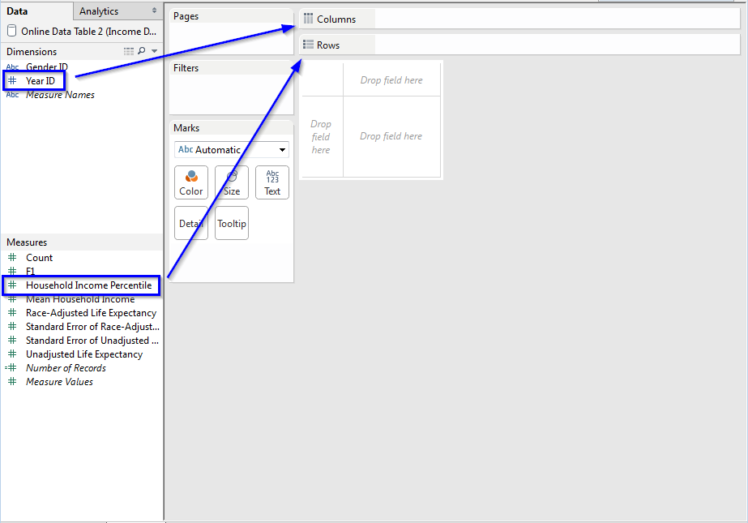

As a result, we will get monochrome view:

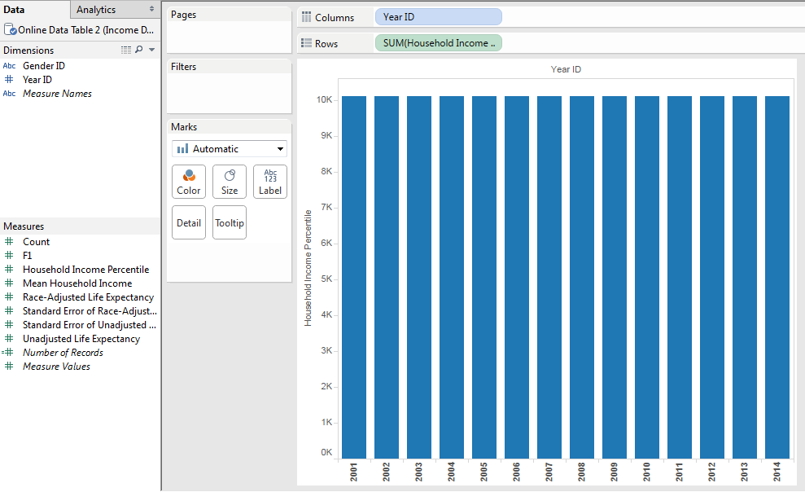



Fixed LOD Calculation



Include LOD Calculation

Functions Over LOD Calculations

Exclude LOD Calculation

Final Sheet

Let’s provide for this view more details and user Gender ID as Colors for Chart.

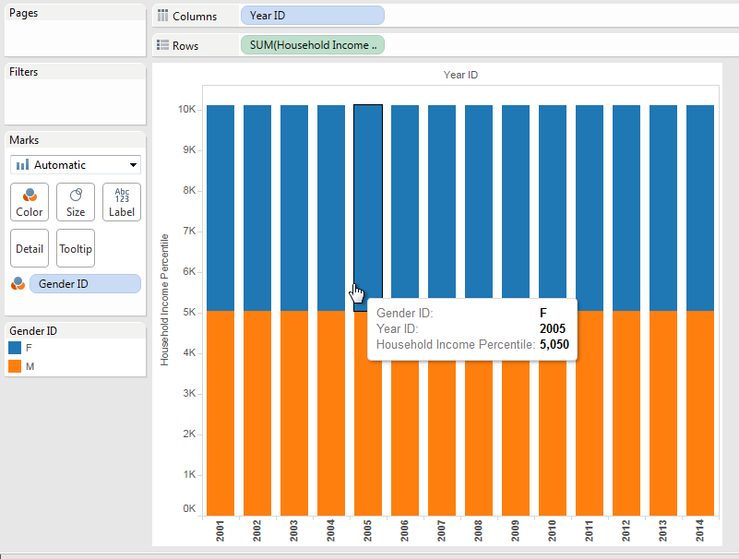

## Now taking place use FIXED Calculations.

Let’s create new Calculated Field. At the field, we will use standard for LOD syntax at curl braces.

We will quickly remind it syntax:

1. The first element after the opening curly brace is one of the following scoping keywords: INCLUDE, EXCLUDE or FIXED.
2. Specifies zero or more dimensions referenced by the scoping keyword when evaluating the aggregate expression.
3. The aggregate expression is the calculation performed.
4. The entire level of detail expression is enclosed in curly braces.

According this let’s create simple LOD field for showing ‘House Income by Year’:



Fixed LOD Calculation



Include LOD Calculation

Functions Over LOD Calculations

Exclude LOD Calculation

Final Sheet

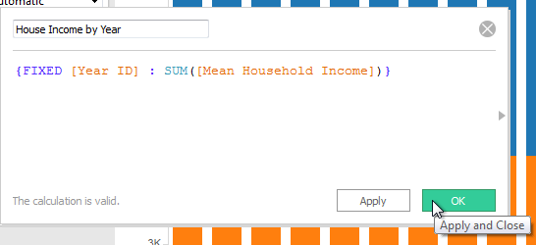

Take in mind that:

* FIXED level of detail expressions compute values using the specified dimensions without reference to the view level of detail—that is, without reference to any other dimensions in the view.
* FIXED level of detail expressions also ignores all the filters in the view other than context filters, data source filters, and extract filters.

## Let’s use newly created calculation field at our sheet.

We will replace summary of Household Income Percentile by new House Income by Year. Also, we can improve our chart by adding House Income by Year as Filter and provide possibility to edit it from sheet.

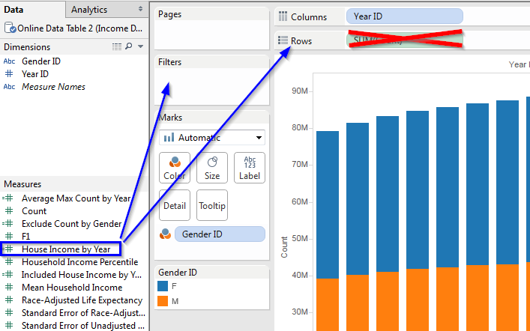



Fixed LOD Calculation



Include LOD Calculation

Functions Over LOD Calculations

Exclude LOD Calculation

Final Sheet

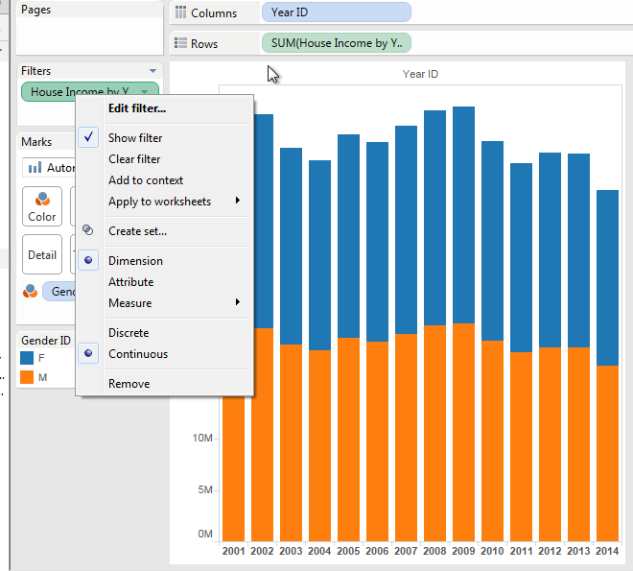

# Include LOD Calculation



Fixed LOD Calculation



Include LOD Calculation

Functions Over LOD Calculations

Exclude LOD Calculation

Final Sheet



## Sheet Preparation

For each example, we will use a new Worksheet:

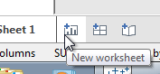

Later we won’t stop at this step any more, just take it in mind.

As next example, we try to display Household Income Percentile by Gender ID, and use first one as Columns and Gender ID as Rows:

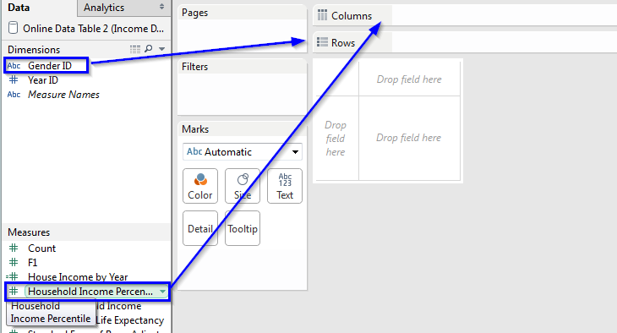

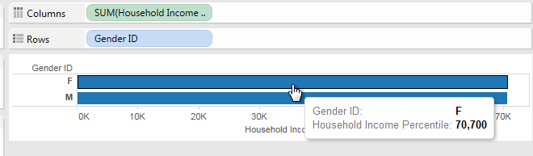

As you can see, now we have just simple Bar Chart. This is a nice place for using Include LOD Calculation.



Fixed LOD Calculation



Include LOD Calculation

Functions Over LOD Calculations

Exclude LOD Calculation

Final Sheet



## Included House Income by Year

Our sheet is prepared, time for create Included LOD Calculation.

Let’s remind that scheme for all LOD Calculation is same and Include Calculation is:

* INCLUDE level of detail expressions compute values using the specified dimensions in addition to whatever dimensions are in the view.
* INCLUDE level of detail expressions are most useful when including a dimension that isn’t in the view.

According this let’s create simple LOD field for showing ‘Included House Income by Year’

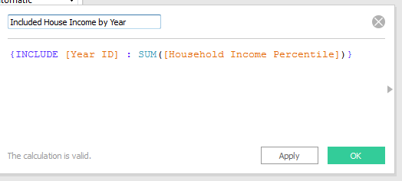

## Let’s use newly created calculation field at our sheet.



Fixed LOD Calculation



Include LOD Calculation

Functions Over LOD Calculations

Exclude LOD Calculation

Final Sheet



We will replace summary of Household Income Percentile by new Included House Income by Year. Also, we will use it as Filter for filtering data at sheet and set different Colors by Year Id dimension.

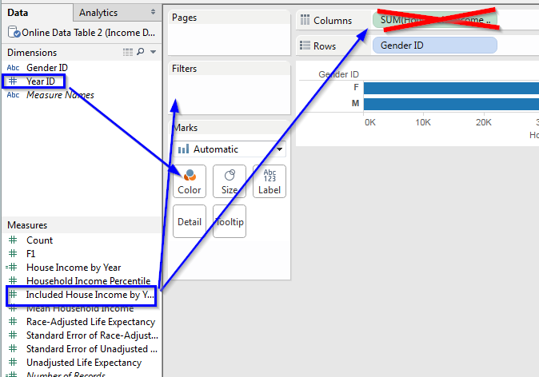

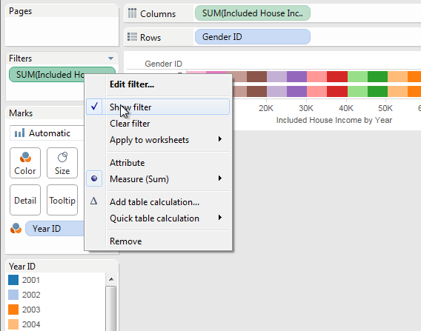

# Functions Over LOD Calculations



Fixed LOD Calculation



Include LOD Calculation

Functions Over LOD Calculations

Exclude LOD Calculation

Final Sheet



## Creating complicated calculated field.

At calculation fields, we can use different complicated operations, it’s also connect with LOD fields. In new sheet, we will use new ‘Average Max Count by Year’ calculation field with next definition:

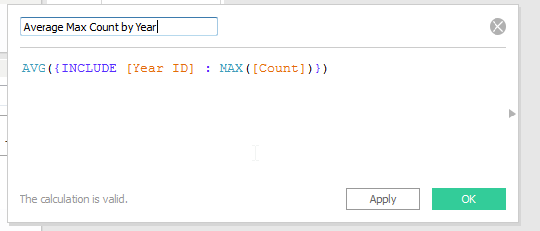

## Using Average Max Count by Year

At new sheet as Columns we will use Average Max Count by Year and as Rows we will use House Incode by Year calculated field:

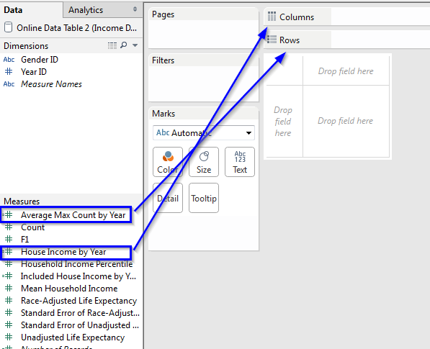



Fixed LOD Calculation



Include LOD Calculation

Functions Over LOD Calculations

Exclude LOD Calculation

Final Sheet



Now our sheet provides too few details, we can improve it by using Year Id as Color, Detail and Label Marks for out Sheet

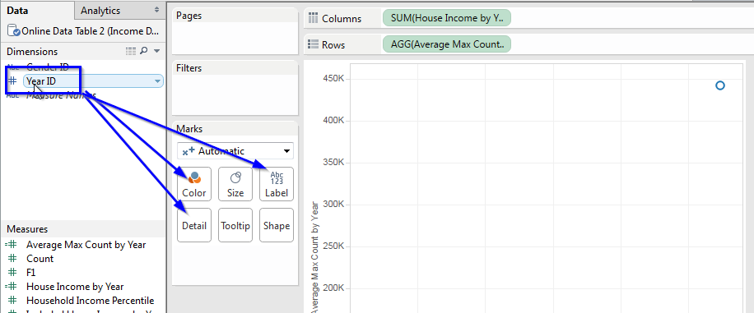

Now our result is more informed and user friendly.

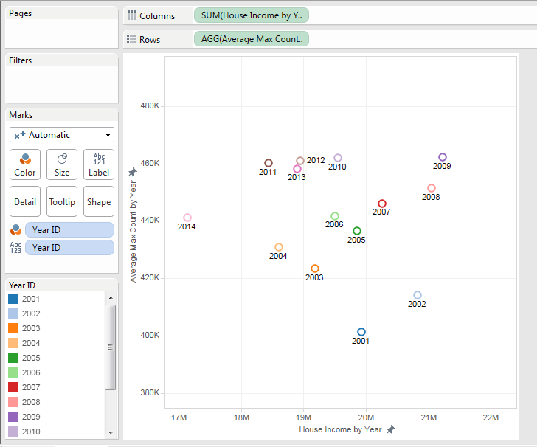

# Exclude LOD Calculation



Fixed LOD Calculation



Include LOD Calculation

Functions Over LOD Calculations

Exclude LOD Calculation

Final Sheet



## Creation of Exclude Calculation Field

At our next example, we will use Exclude LOD Calculation. Let’s quickly go through that LOD definition:

* EXCLUDE level of detail expressions explicitly remove dimensions from the expression—that is, they subtract dimensions from the view level of detail.
* EXCLUDE level of detail expressions are most useful for eliminating a dimension in the view.

For better understanding difference between Include and Exclude LOD Calculation please check data example in picture below:

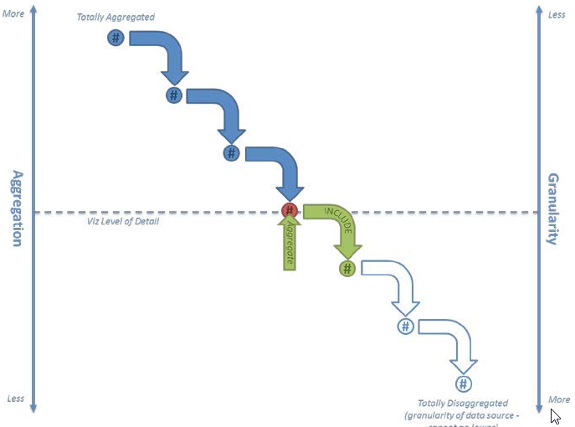

Definition of new field Exclude Count by Gender will be next:



Fixed LOD Calculation



Include LOD Calculation

Functions Over LOD Calculations

Exclude LOD Calculation

Final Sheet



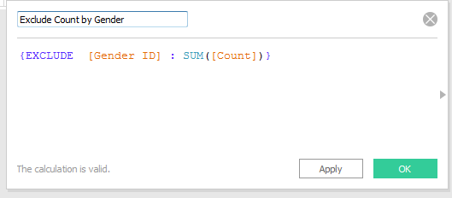

## Using Exclude LOD Calculation field

As example chart we will use Count measure and Gender Id dimension for Columns and Year Id dimension for Rows:

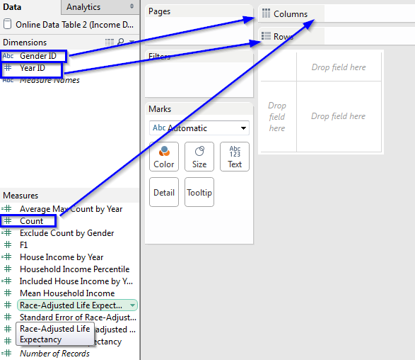

Let’s use our Exclude calculation field as Color provider for sheet:



Fixed LOD Calculation



Include LOD Calculation

Functions Over LOD Calculations

Exclude LOD Calculation

Final Sheet



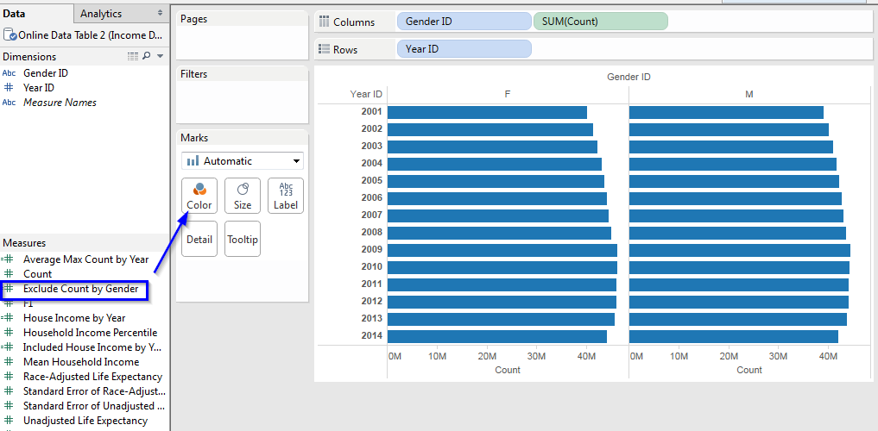

We will change default color scheme into one of Colors or into one of predefined Palette template. For make it we just need to Right Click on created ATTR(Exclude Count by Gender) color filter and choose Edit colors… option from context menu for that field.

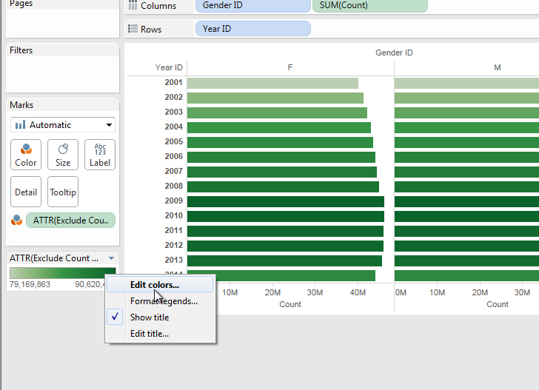

And change proper Colors at available editor.



Fixed LOD Calculation



Include LOD Calculation

Functions Over LOD Calculations

Exclude LOD Calculation

Final Sheet



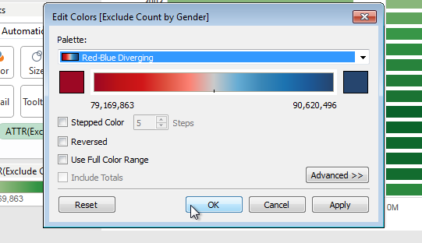

After applying we should see something like at photo below:

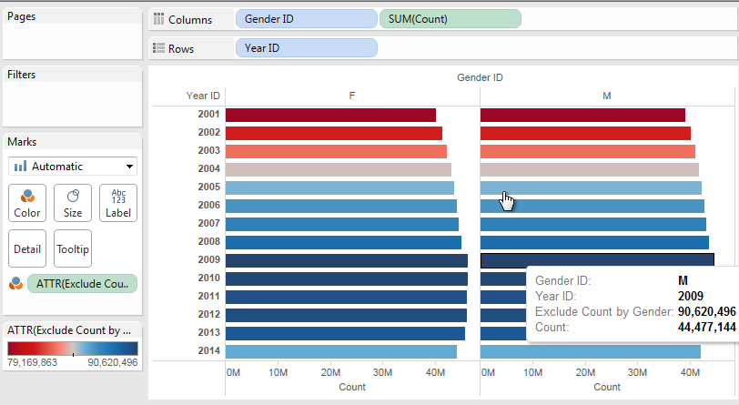

# Final Sheet



Fixed LOD Calculation



Include LOD Calculation

Functions Over LOD Calculations

Exclude LOD Calculation

Final Sheet



## Sheet Preparing

In the last sheet, we will use all LOD fields created during the laboratory. We will start from preparing new sheet with Columns and Rows:

* As Rows, we will use Year Id dimension.
* As Columns, we will use Gender Id dimension.

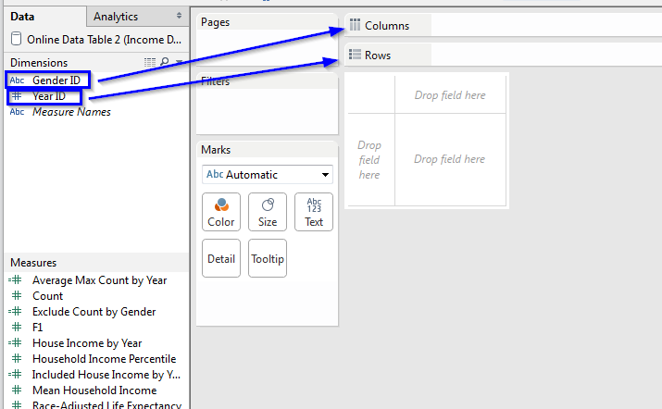

## Using all LOD Calculation fields

Now we can extend our Columns with next LOD fields:

* Average Max Count by Year
* House Income by Year
* Included Houses Income by Year

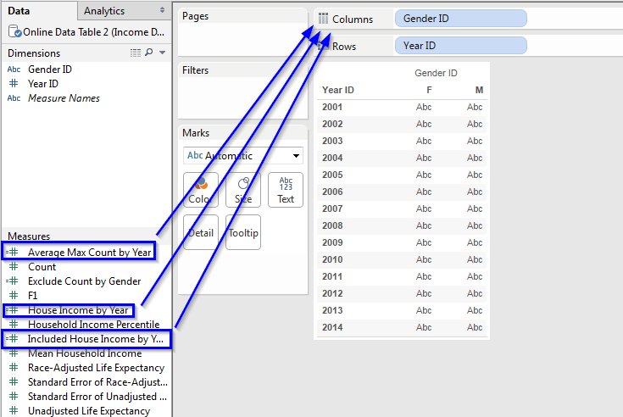



Fixed LOD Calculation



Include LOD Calculation

Functions Over LOD Calculations

Exclude LOD Calculation

Final Sheet



And use LOD field – Exclude Count by Gender, as color provider.

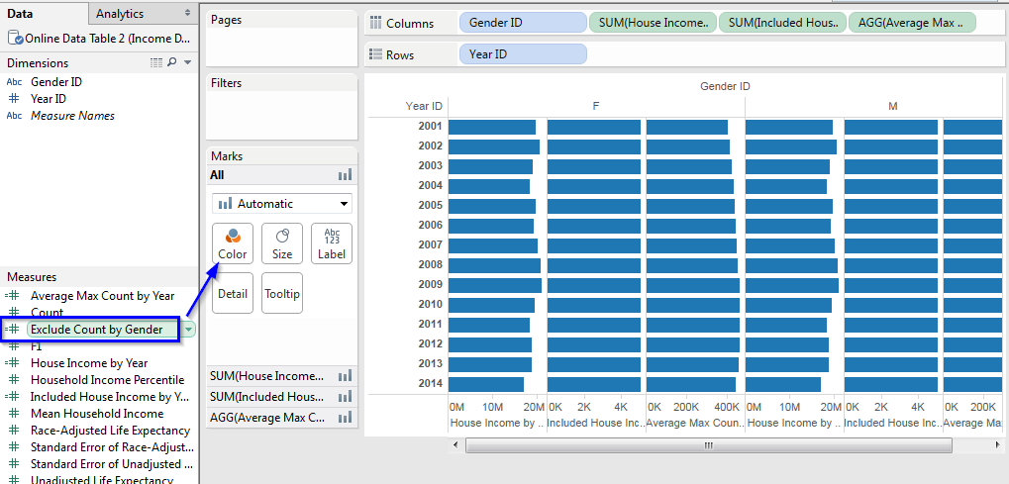

Simply change Colors palette on the one that you like.



Fixed LOD Calculation



Include LOD Calculation

Functions Over LOD Calculations

Exclude LOD Calculation

Final Sheet



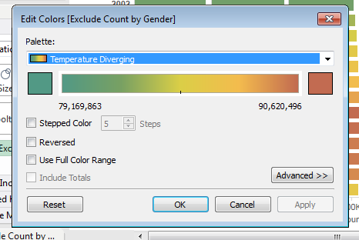

And this is it – our Final Sheet is done:

